
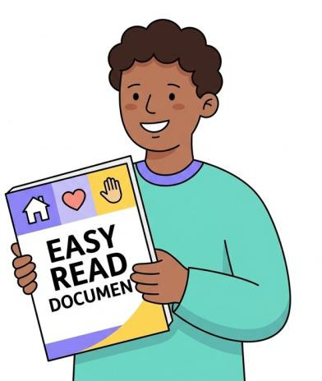

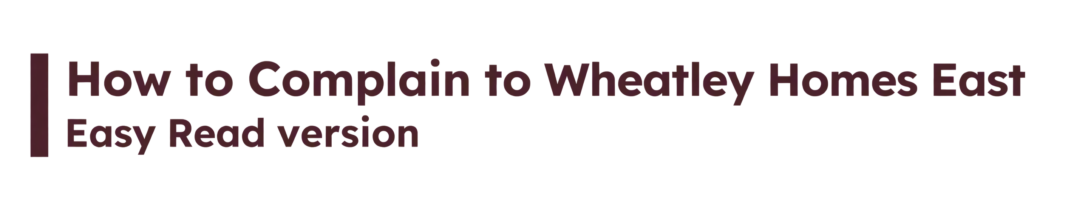

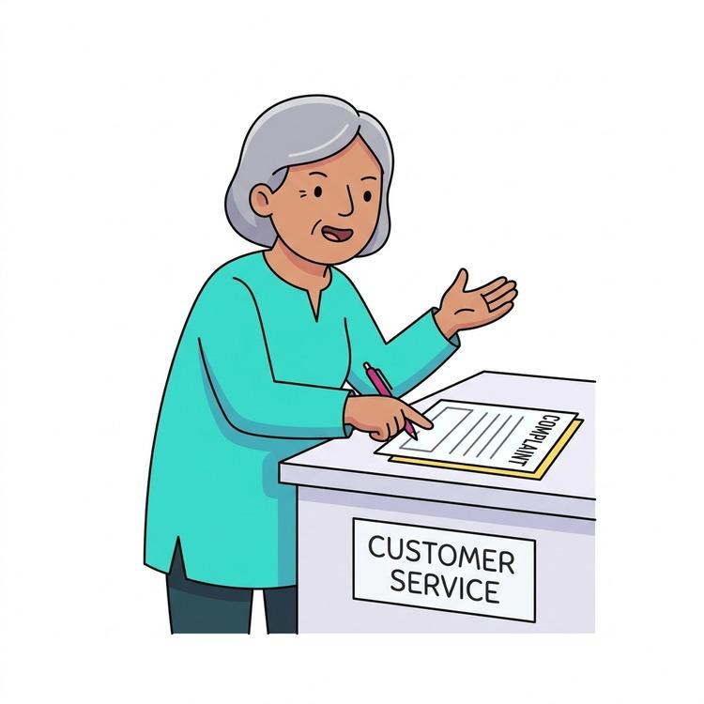



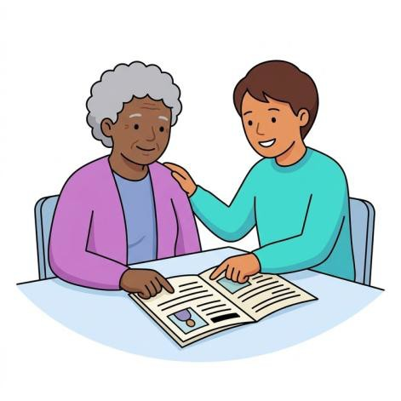
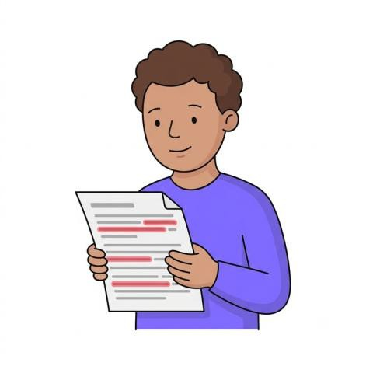

This is an Easy Read document. Easy Read uses simple words and pictures to help you understand.

You may still want help to read this document.
This document may not have all the information. We will tell you the most important parts.

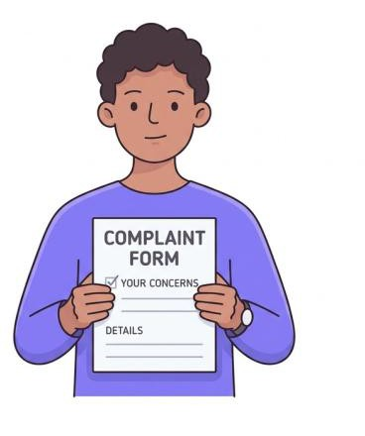


What is a complaint? | 5
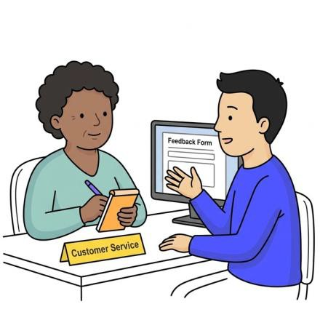 Who can complain | 5
 How to complain | 6
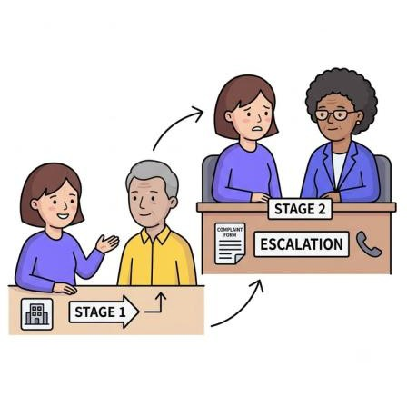 Stage 1 of our complaints process | 6
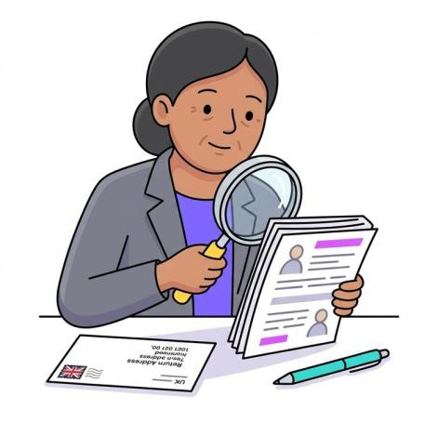 Stage 2 of our complaints process | 7
Children and young people | 8

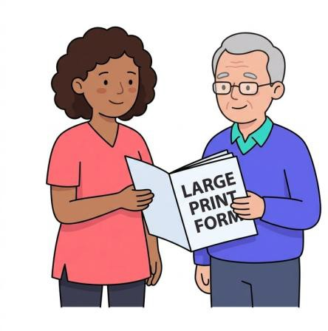
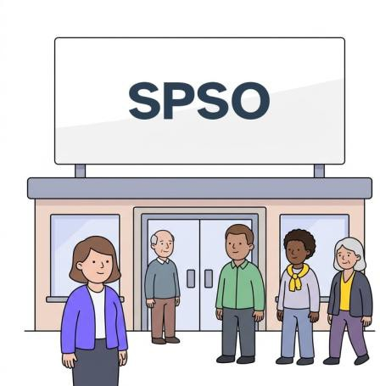

Accessible support | 9
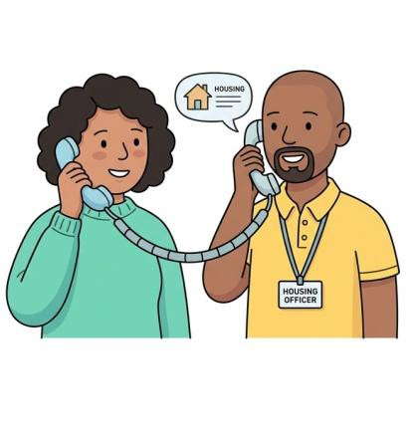  Contacting Wheatley Homes East for a Stage 1 complaint | 10
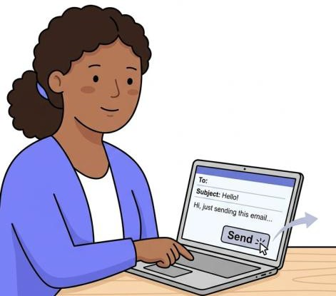  Contacting Wheatley Homes East for a Stage 2 complaint | 11
After the complaint | 12



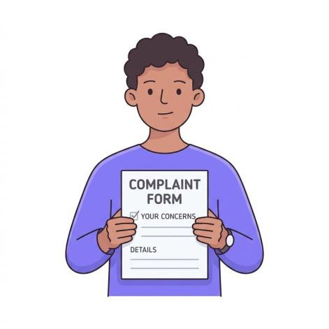

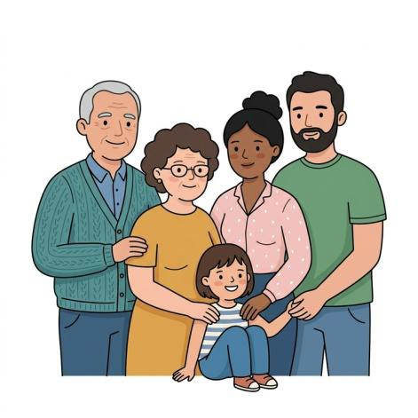

A complaint is when you want to tell us you are unhappy with our service.

Anyone who uses or asks for a Wheatley Homes East service can complain.

Children and young people can also complain.



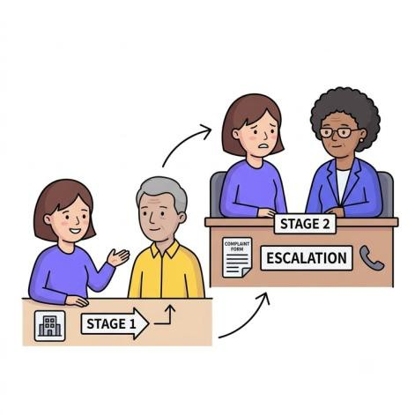
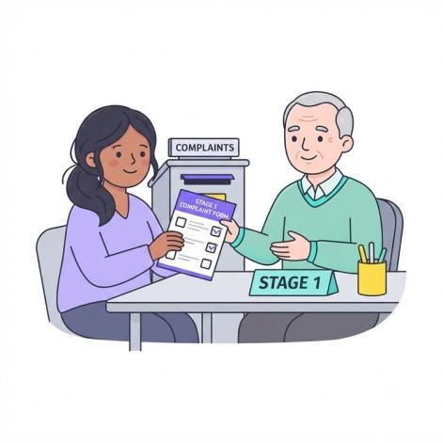

You can complain in person, by phone, email, online, or in writing.

Our complaints process has two stages.

At stage 1, we will try to fix your complaint quickly.

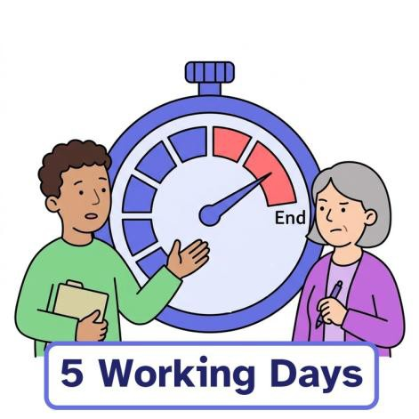
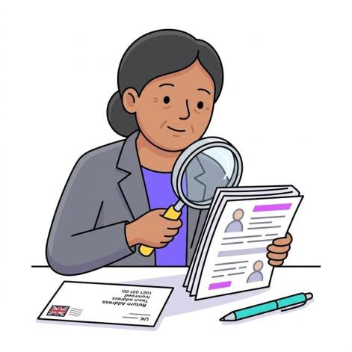
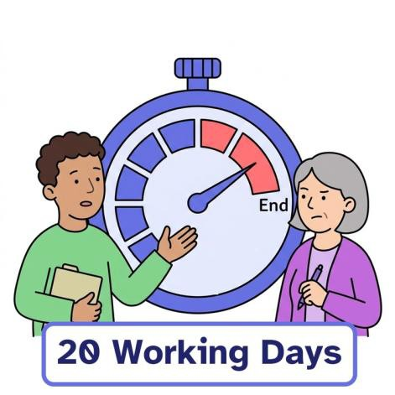

We aim to reply within five working days.

If you are not happy with Stage 1, we can look at your case again.

We aim to reply within 20 working days.

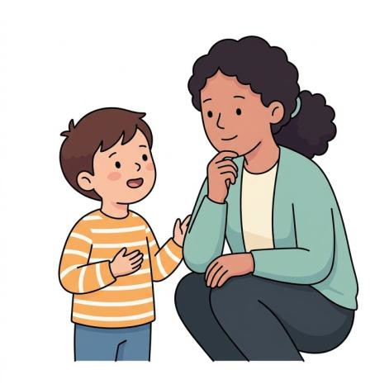

We will think about what is best for the child.

We will listen to children and use clear words.



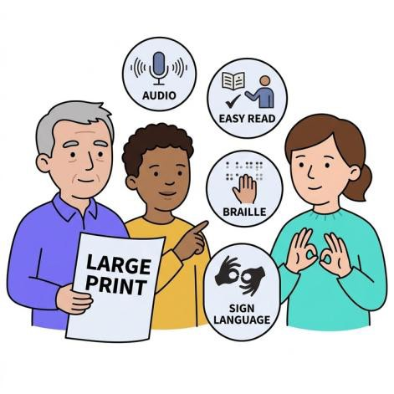

You can ask for these formats if you need them.

We can give you large print, Braille, translations, and other formats.

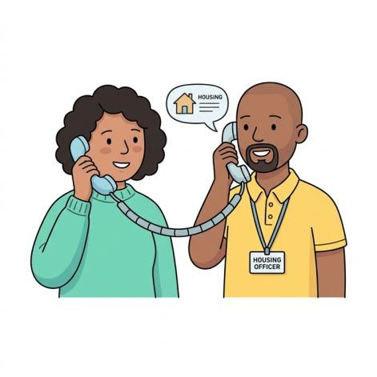
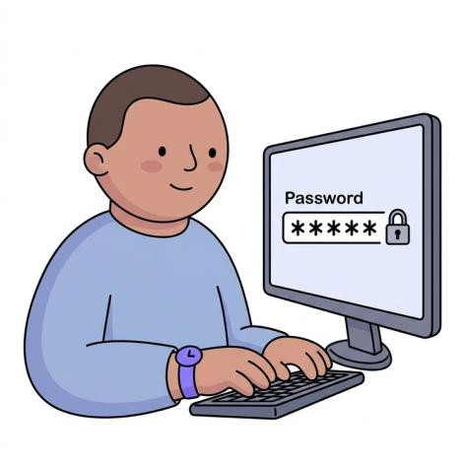
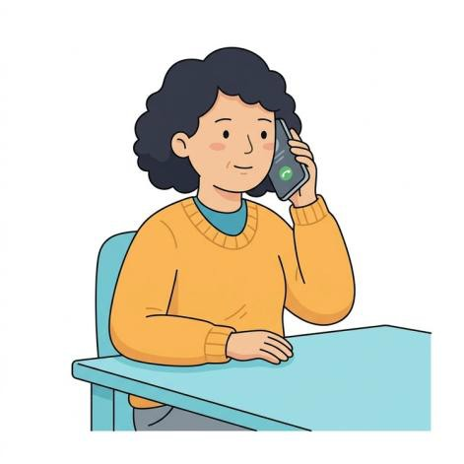

You can talk to your housing officer.

You can report the complaint through your online account.

You can call Wheatley Homes East on 0800 561 0088.

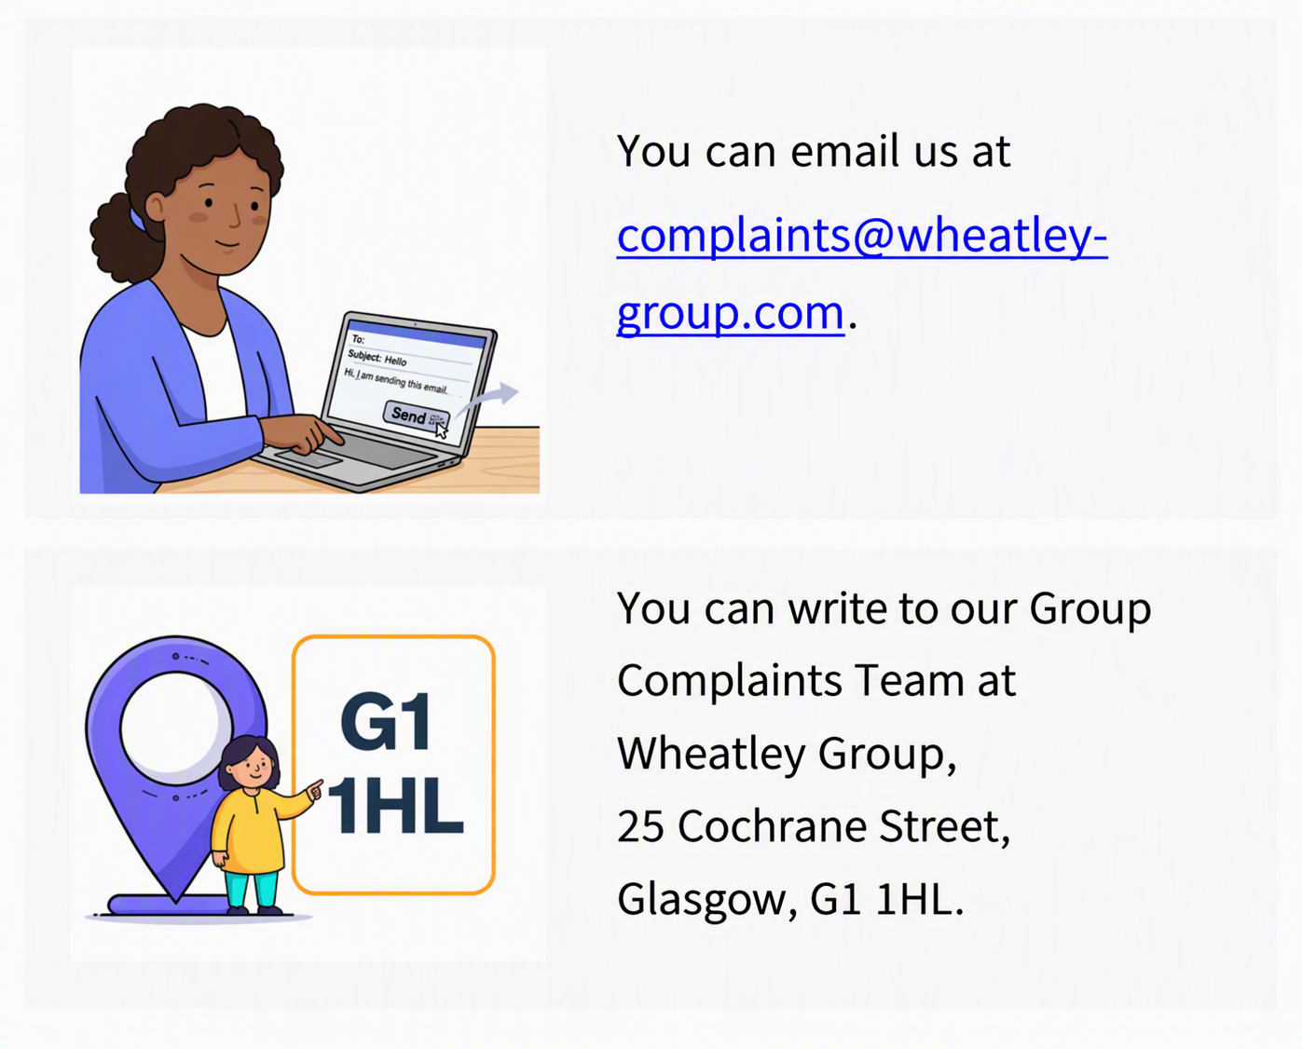

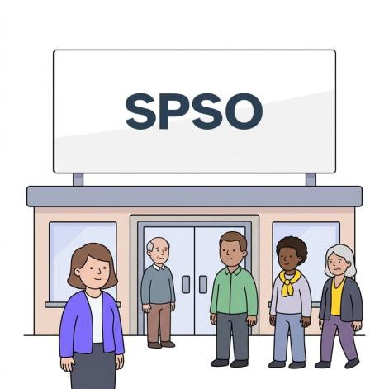
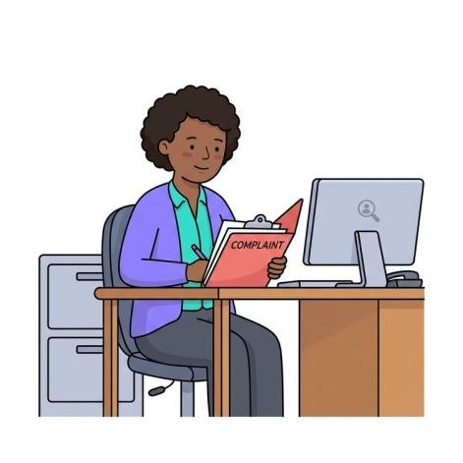
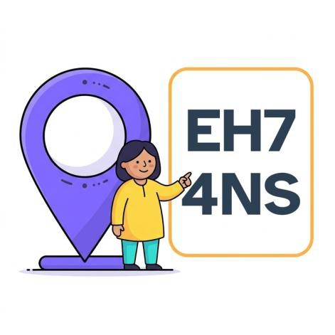

If you are still unhappy, you can contact the Scottish Public Services Ombudsman (SPSO).

The SPSO looks at complaints in Scotland independently.
You can write to the SPSO at Bridgeside House, 99 McDonald Road, Edinburgh EH7 4NS.

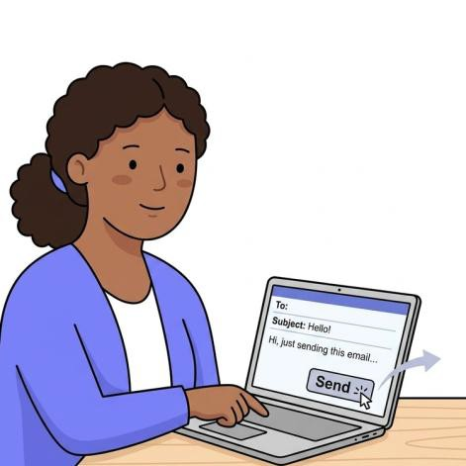

You can call the SPSO on 0800 377 7330.

You can email the SPSO at ask@spso.org.uk.

Pictures by Claru or in the public domain unless otherwise stated.

